
SCHOOL OF COMPUTING AND ENGINEERING SCIENCES (SCES)
BACHELOR OF SCIENCE IN ELECTRICAL AND ELECTRONICS ENGINEERING (BSEEE)
SEMESTER TWO: CHEMISTRY LAB 3
By
Mwongela Edward Aribu 142092
Collaborators
Teddy Mbugua - 142776
Mark Mbiriri - 143389
Arnold Injeni - 146279

Abstract
This is a report that contains the data obtained in a laboratory experiment conducted in the Strathmore engineering laboratories by the group members listed above. It covers single displacement reactions, synthesis reactions, and Dalton’s law of multiple proportions

Table of Contents
Abstract 2
Table of figures 4
INTRODUCTION 5
LITERATURE REVIEW 6
EXPERIMENT ONE: SINGLE DISPLACEMENT REACTION: FORMATION OF COPPER METAL 7
METHODOLOGY 7
Requirements 7
Procedures: 7
RESULTS AND FINDINGS 7
EXPERIMENT TWO: SYNTHESIS REACTION: FORMATION OF THE COORDINATION COMPLEXES 10
METHODOLOGY 10
Requirements 10
Procedures 10
RESULTS AND FINDINGS 10
EXPERIMENT THREE: DALTON’S LAW: LAW OF MULTIPLE PROPORTIONS 11
METHODOLOGY 11
Requirements 11
Procedures 11
RESULTS AND FINDINGS 13
REFERENCES 29

Table of figures
Figure 1 8
Figure 2 9
Figure 3 13
Figure 4 13
Figure 5 14
Figure 6 14
Figure 7 15
Figure 8 16
Figure 9 17
Figure 10 18
Figure 11 19
Figure 12 20
Figure 13 21
Figure 14 22
Figure 15 23
Figure 16 24
Figure 17 25
Figure 18 26
Figure 19 27
Figure 20 28

INTRODUCTION

Brief introduction (single displacement reaction: formation of copper metal)
A single-displacement reaction, also known as single replacement reaction or exchange reaction, one wherein the atom or a set of atoms is displaced by another atom in a molecule. For instance, when iron is added to a copper sulphate solution, it displaces the copper metal

Objective
Observing how cupric ion is transformed into copper metal

1.0.2 brief introduction: synthesis reaction: (formation of coordination complexes)
In chemistry, a synthesis reaction is when two or more chemicals combine and form a more complex product. You will also have more reactants than products since two or more chemical species combine to form one new larger compound

Objective
Observing how coloured complex ions are formed.

1.0.3 brief introduction: (Dalton’s law of multiple proportions)
law of multiple proportions is a law stating that if two elements form a compound, then the ratio of the mass of the second element and the mass of the first element will be small whole number ratios.

Objective
Observe the ratio between amount copper obtained and original amount of salt

LITERATURE REVIEW

single displacement reaction: formation of copper metal
displacement reaction is the one wherein the atom or a set of atoms is displaced by another atom in a molecule. For instance, when iron is added to a copper sulphate solution, it displaces the copper metal.
A + B-C → A-C + B
The above equation exists when A is more reactive than B.
A and B have to be either:
- Halogens where C indicates a cation.
- Different metals wherein C indicates an anion.(Displacement Reactions - Definition, Types (Single & Double), Examples, n.d.)
A single displacement reaction which is also called as single replacement reaction is a kind of oxidation-reduction when an ion or element moves out of a compound, i.e., one element is replaced by the other in a compound.
Double displacement reactions occur when a part of two ionic compounds is exchanged and make two new components.
Double displacement reactions take place mostly in aqueous solutions wherein the ions precipitate and exchange of ions takes place.
For example, when a solution of barium chloride is mixed with sodium sulphate, a white precipitate of barium sulphate is formed rapidly. These reactions are ionic in nature. The reactants get transformed into ions when dissolved in water and exchange of ions occur in the solution and results in the formation of a product molecule.

Synthesis reaction
In a synthesis reaction, two or more chemical species combine, forming a more complex product in the reaction. It is also called a direct reaction and is one of the most common chemical reactions. When the two or more reactants combine, they make a larger compound. A synthesis reaction is the opposite of a decomposition reaction, which is when the bonds are broken in a complex product, and it splits the product into its respective components or elements.
The basic form of the chemical equation is written as:
A + B → AB
Organic synthesis reactions involve organic compounds. Organic molecules are more complex than their inorganic counterparts are. In many cases, because of the complexity, synthesis reactions of organic compounds require several steps one after the other to create a single product. This makes intermediate compounds for each step before the final single product.(What Is a Synthesis Reaction?, n.d.)
For example, when water combines with ethyl leads it forms ethanol or:
CH₂ = CH₂ + HCl → CH₃ -CH₂Cl
A synthesis reaction can occur when combining elements and producing a new compound, combining compounds to produce a new compound, or combining both elements and compounds to result in a new compound.
When a metal and non-metal are combined, they produce an ionic compound.
When two non-metals combine, they produce a covalent compound.
When combining metal oxide and water (both compounds), it produces a new compound of a metal hydroxide.
Non-metal and water combinations result in an oxy acid compound.
Metal oxides and carbon dioxide combined produce metal carbonates.

Dalton’s law of multiple proportions
The law of multiple proportions, also known as Dalton’s law, was proposed by the English chemist and meteorologist John Dalton in his 1804 work, A New System of Chemical Philosophy. It is a rule of stoichiometry. The law, which was based on Dalton’s observations of the reactions of atmospheric gases, states that when elements form compounds, the proportions of the elements in those chemical compounds can be expressed in small whole number ratios.
For example, the reaction of the elements carbon and oxygen can yield both carbon monoxide (CO) and carbon dioxide (CO₂). In CO₂, the ratio of the amount of oxygen compared to the amount of carbon is a fixed ratio of 1:2, a ratio of simple whole numbers. In CO, the ratio is 1:1.
In his theory of atomic structure and composition, Dalton presented the concept that all matter was composed of different combinations of atoms, which are the indivisible building blocks of matter. Dalton’s law of multiple proportions is part of the basis for modern atomic theory, along with Joseph Proust’s law of definite composition (which states that compounds are formed by defined mass ratios of reacting elements) and the law of conservation of mass that was proposed by Antoine Lavoisier. These laws paved the way for our current understanding of atomic structure and composition, including concepts like molecular or chemical formulas.(The Law of Multiple Proportions | Introduction to Chemistry, n.d.)

EXPERIMENT ONE: SINGLE DISPLACEMENT REACTION: FORMATION OF COPPER METAL
Objective: Observing how cupric ion is transformed into copper metal

METHODOLOGY

Requirements
i. Test tube rack
ii. Wash bottle
iii. Steel wool
iv. Short test tube
v. Copper (II) sulphate
vi. Rod
Caution! The solutions containing copper are toxic if swallowed. Always wear protective goggles and gloves.

Procedures:
1- Insert a tube in the tube rack and pour water into it up to half volume. Then pour a teaspoon of copper sulphate and shake to obtain a homogeneous solution.
2- Insert the steel wool in the test tube until it is immersed in the solution.
3- Observe the formation of red metallic copper and the disappearance of the blue colour in the solution.
Report your findings explaining the process of the formation with equations and energy exchange processes

RESULTS AND FINDINGS

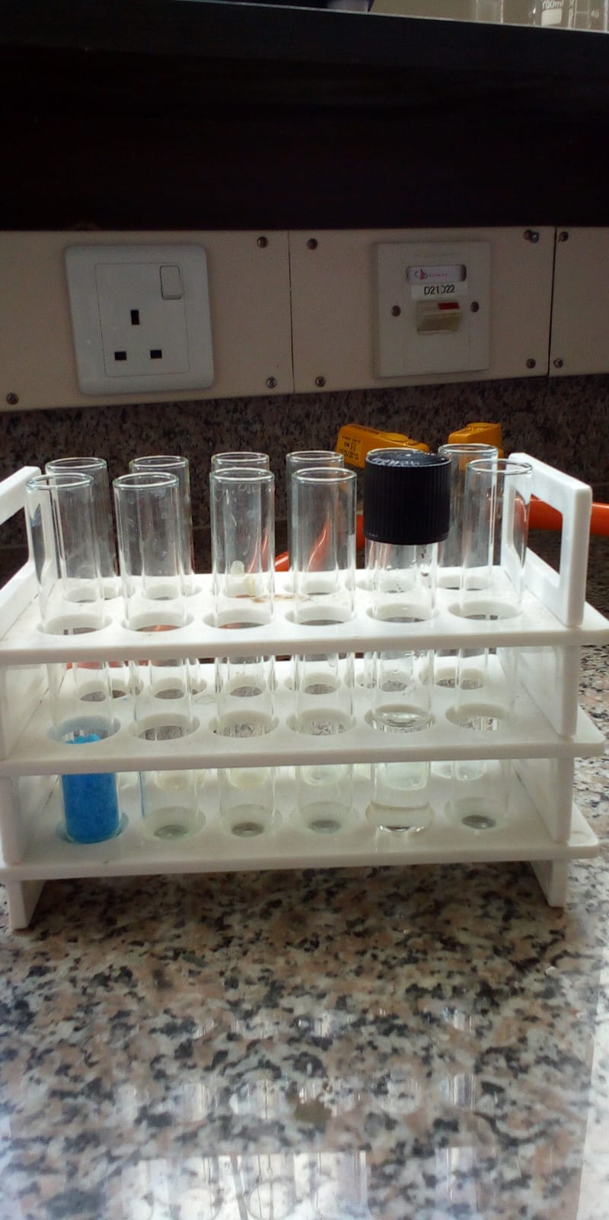
Figure 1
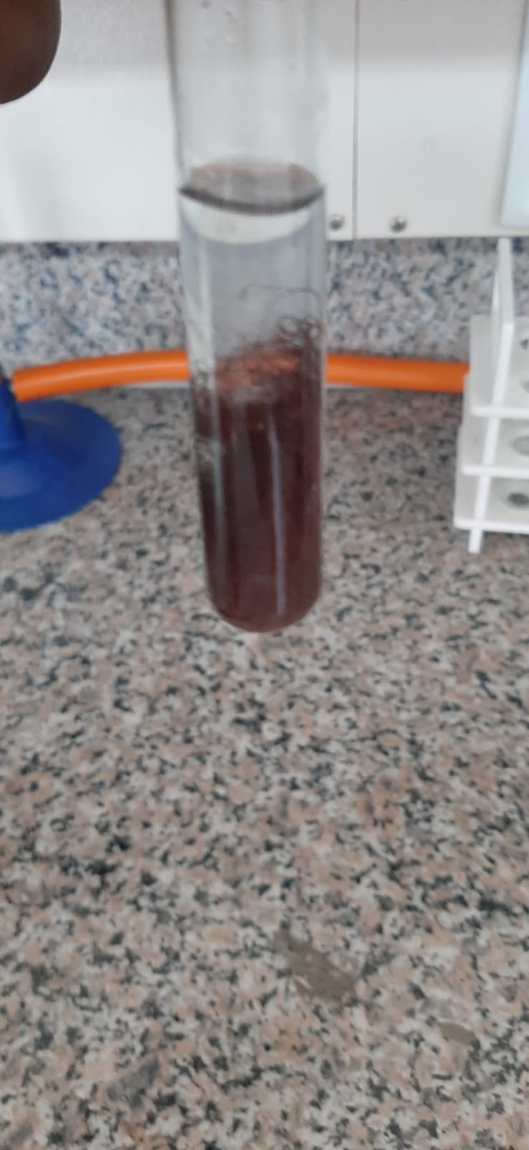
Figure 2

The blue copper (II) sulphate solution turns colourless due to displacement of copper by iron and copper is deposited on the ion wool as a red metal
Cu (II)SO₄ + Fe$→$ Cu +Fe (II)SO₄
There are two processes:
Cu²⁺ + 2e = Cu⁰ (reduction process, Cu²⁺ is the oxidizing agent.
Fe⁰ – 2e = Fe²⁺ (oxidation process, Fe⁰ is the reducing agent).

EXPERIMENT TWO: SYNTHESIS REACTION: FORMATION OF THE COORDINATION COMPLEXES
Observative: Observing how coloured complex ions are formed.
Caution! The solutions containing copper are toxic if swallowed. Always wear protective goggles and gloves

METHODOLOGY

Requirements
i. Test tube rack
ii. Beaker and spatula
iii. Sodium chloride
iv. Small test tube
v. Copper (II) Sulphate
vi. Ammonia Solution

Procedures
1- Pour half teaspoon of copper (II) sulphate in a dry test tube, then fill half tube with water and shake
2- Pour a teaspoon of sodium chloride in a dry test tube.
3- Pour the clear solution of copper sulphate into a test tube very slowly, without shaking. Observe that a green colouring appears in the lower part because of the formation of copper (II) chloride.
4- Pour some drops of ammonia solution and observe that a dark blue colour appears because of the formation of copper ammonia complex.
Report your findings with explanation of the energy exchange.

RESULTS AND FINDINGS

EXPERIMENT THREE: DALTON’S LAW: LAW OF MULTIPLE PROPORTIONS

METHODOLOGY

Requirements
i. electronic scale
ii. 4 Beakers
iii. 4 Flasks -4 Funnels
iv. Wash bottle – Dropper
v. Spoon spatula
vi. 4 Rods
vii. Watch glass
viii. Filter paper
ix. Copper (I) Chloride
x. Copper (II) Chloride
xi. Aluminium bars
xii. Hydrochloric acid

Procedures
1- Use the scale correctly: place the beaker on it, reset it, then add the substance little until the desired weight in attained.
2- Prepare four beakers on the worktop and mark them with numbers 1,2,3, and 4. Pour 1.7g of copper (II) chloride (CuCl22H2O)
3- Using the watch bottle pour some water into each beaker up to a volume of approximately 50ml
4- Using the dropper add 1 ml of hydrochloric acid solution in beaker 2.
5- Repeat the same operation in the fourth beaker. Shake with the rod to solubilize. A white solid residue can be found in the beaker containing copper (I) chloride.
6- Insert the aluminium bars in all the beakers and observe how copper metal is formed.
7- Let them react for approximately one hour shaking the bars from time to time. The reaction will end when the blue colour of the solution disappears. Prepare the four funnels in the corresponding flasks and insert the filter paper. Extract the bars from the beakers scraping with the plastic spatula to collect all the copper metal.
8- Transfer the content of the beakers into the corresponding funnels. It would be better to mark the filter with a pencil to indicate the corresponding sample. The transfer of the copper metal should be complete; if necessary, add some water with the wash bottle to favour the removal of the solid from the beaker. Wash the solid on the filters three times adding some millilitres of water onto the residue with wash bottles every time. Drain, remove the filters from the funnels and let dry.
9- After drying the filters, continue with the weighing operations.
10- Put the watch glass on the scale, reset and transfer the solid residue with the spatula onto the watch glass very carefully, then record the weight of the sample on the table shown here below. Repeat these operations with all the four samples, then process the data

test | compound | Mass(g) | Collected copper | Combined chlorine | Cu(I)Cl / Cu(II)Cl
1 | CuCl2.2H2O | 1.7(1.3) | 2.01
2 | CuCl | 1.0 | 1.72
3 | CuCl22H2O | 3.4 | 4.11
4 | CuCl | 2.0 | 2.07

The combined chlorine results from the difference between the masses of the reacting salt and of the collected copper. The copper (II) chloride is a salt dihydrate; therefore, in the calculations for determining the combined chlorine, consider that 1.7g of salt dihydrate correspond to 1.3 g of anhydrous salt. The data resulting from the test enable to calculate the minimum formulae of the used copper compounds.
Caution! Copper salts are harmful is swallowed, the hydrochloric acid solution is stinging and corrosive

RESULTS AND FINDINGS
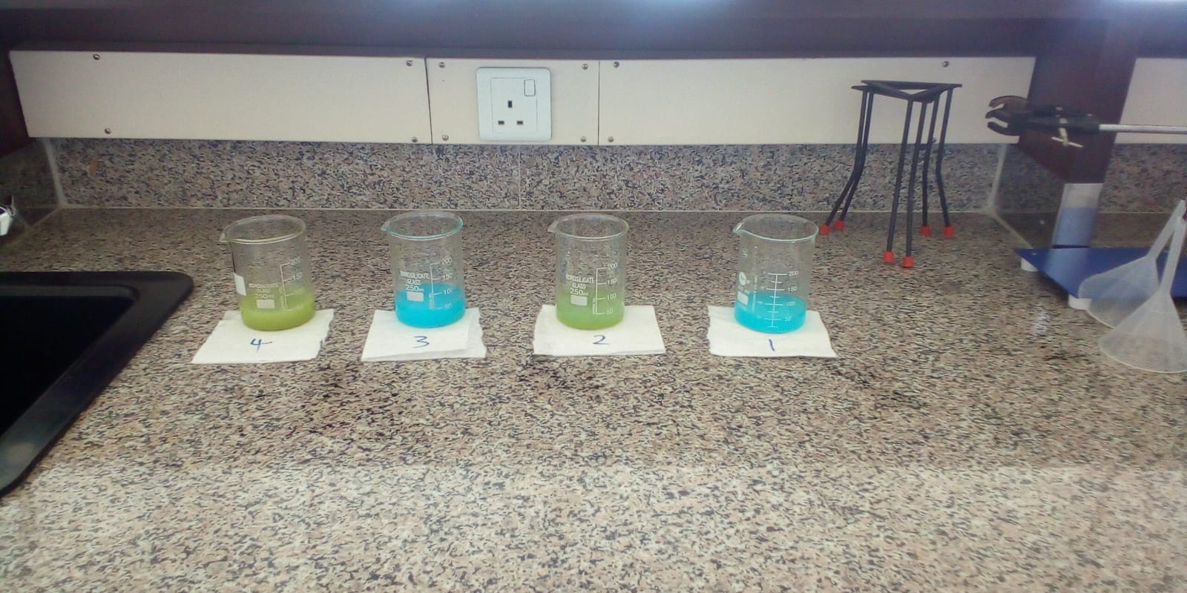
Figure 3

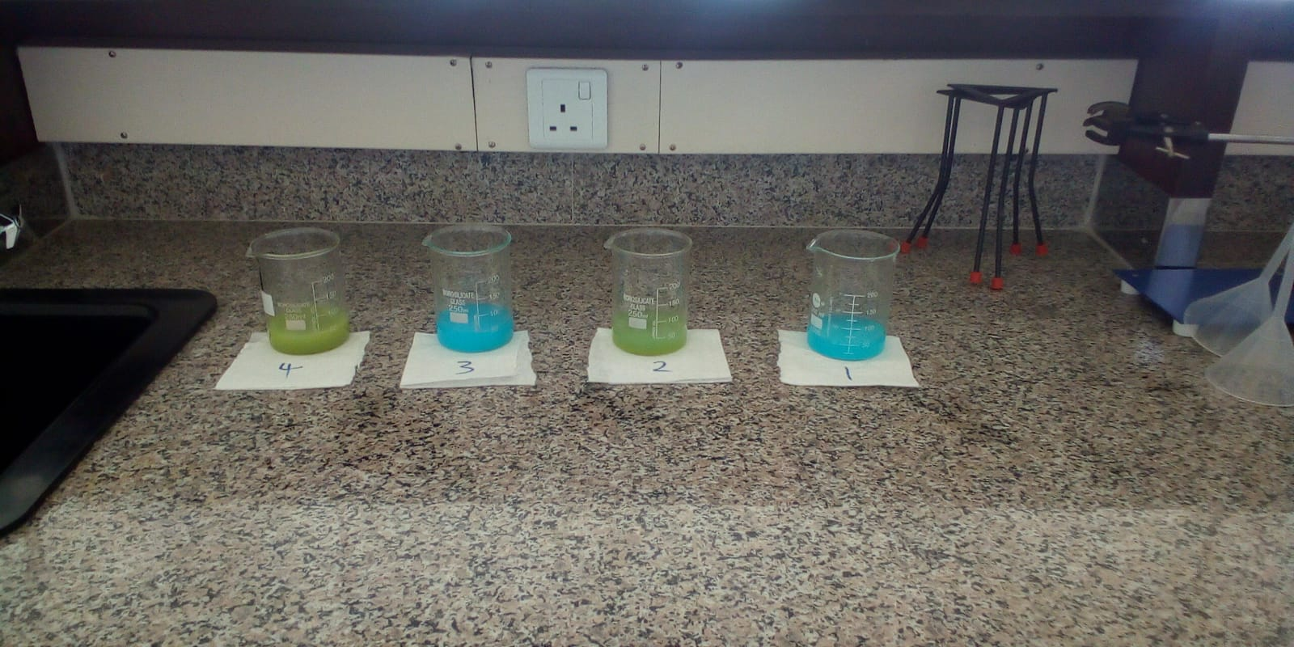
Figure 4
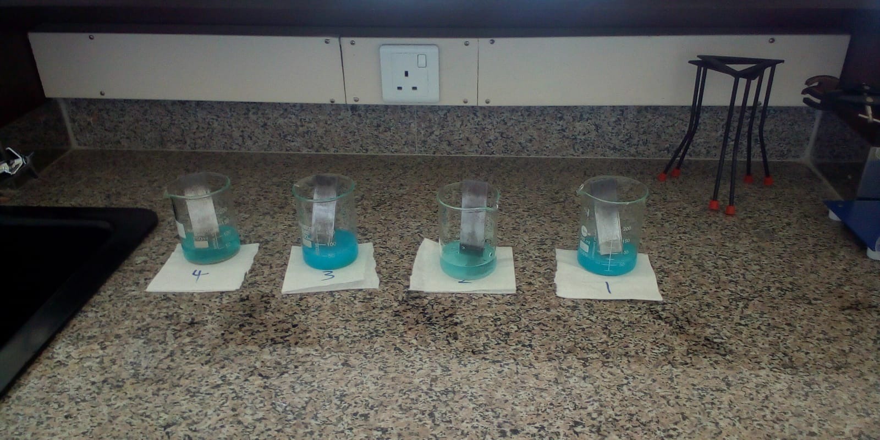
Figure 5

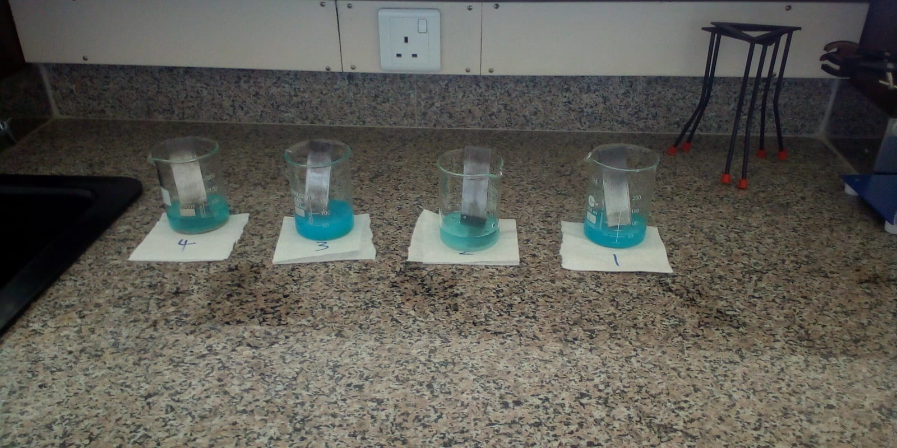
Figure 6
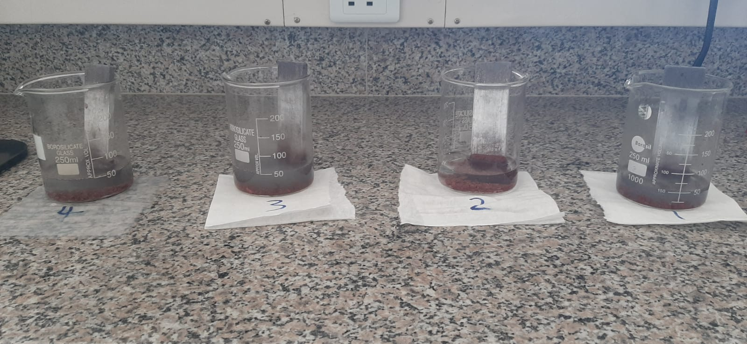
Figure 7
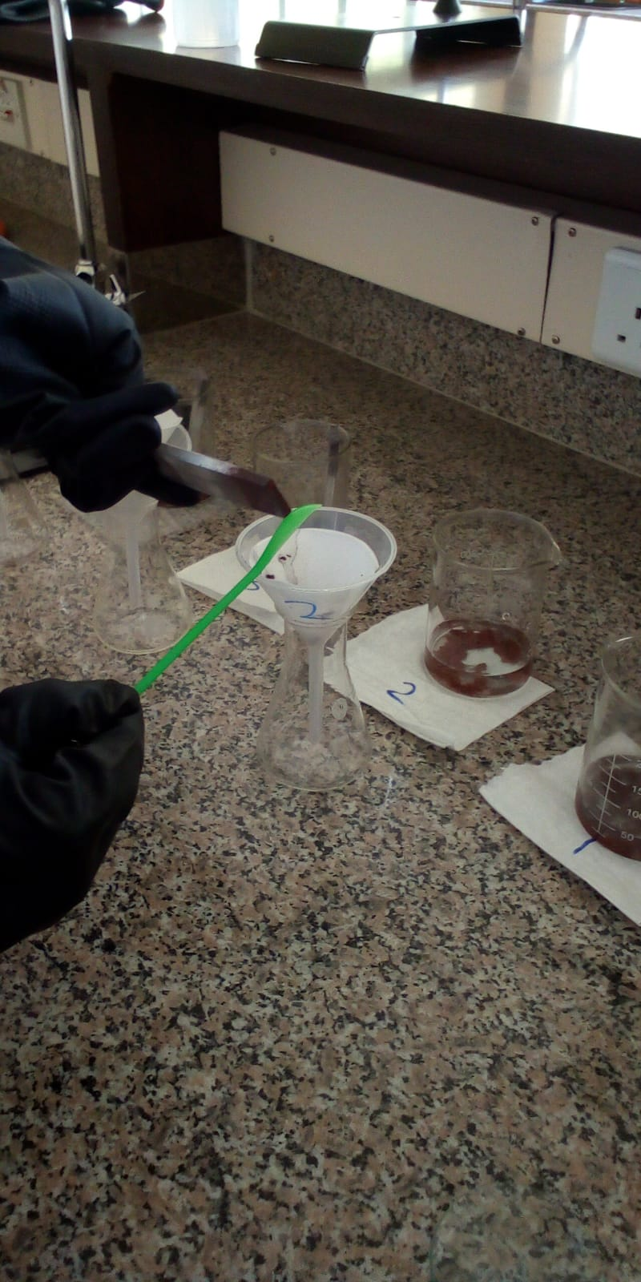
Figure 8
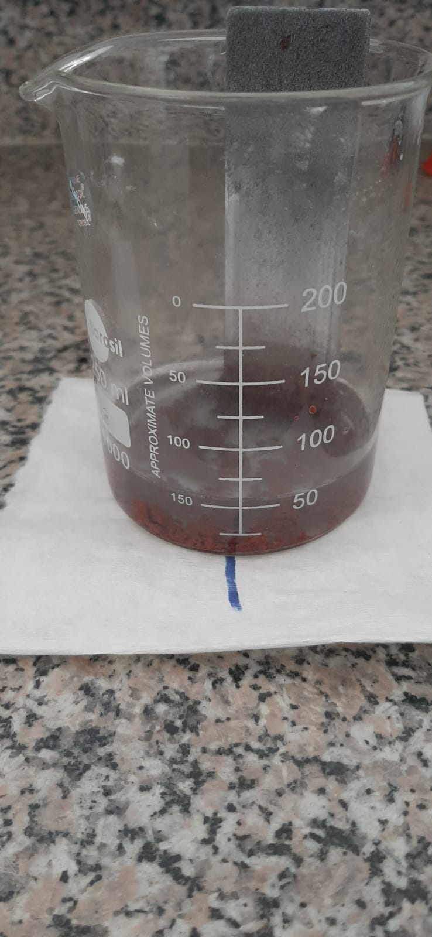
Figure 9
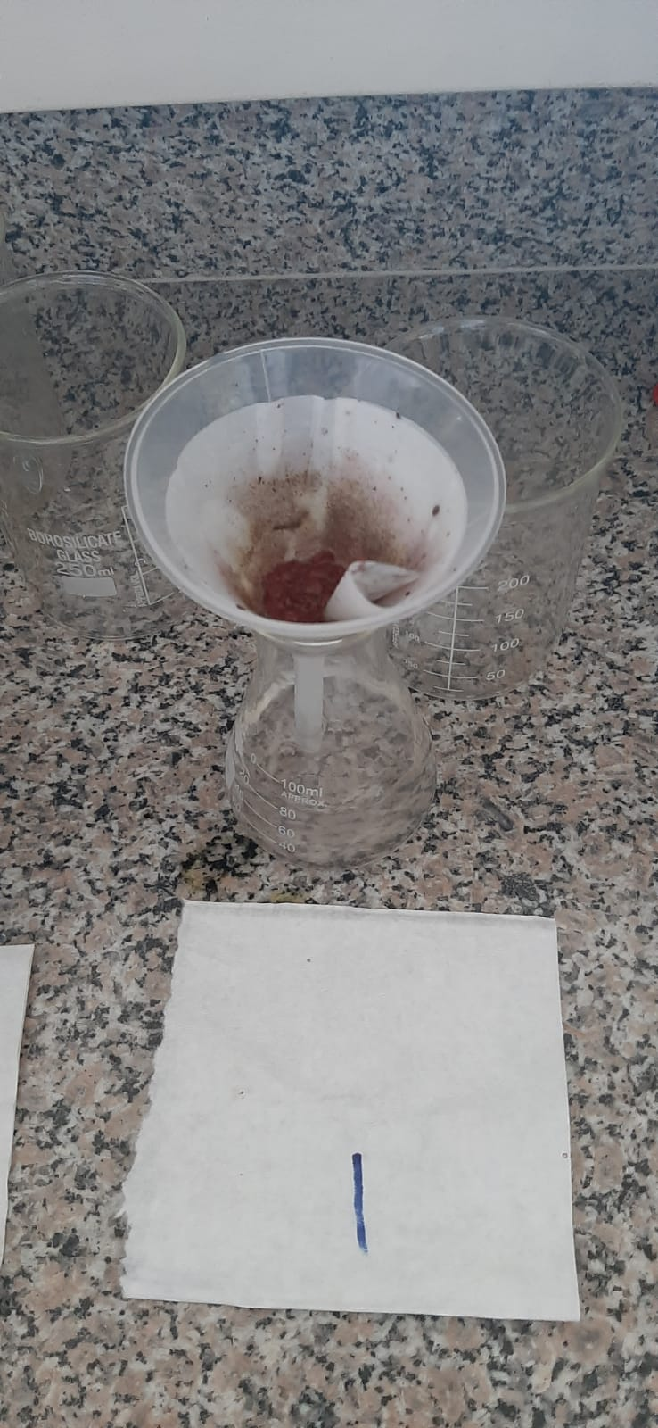
Figure 10

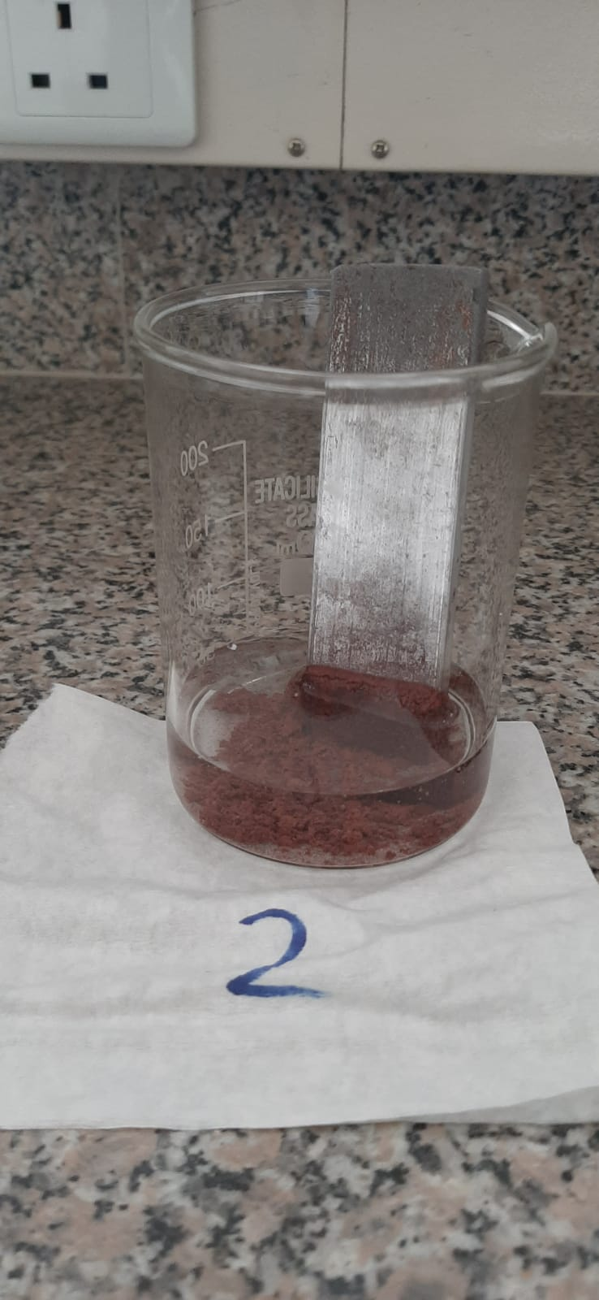
Figure 11

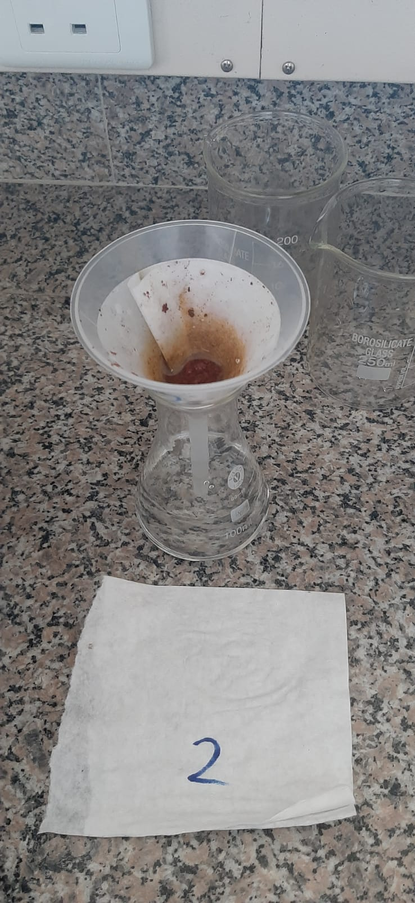
Figure 12

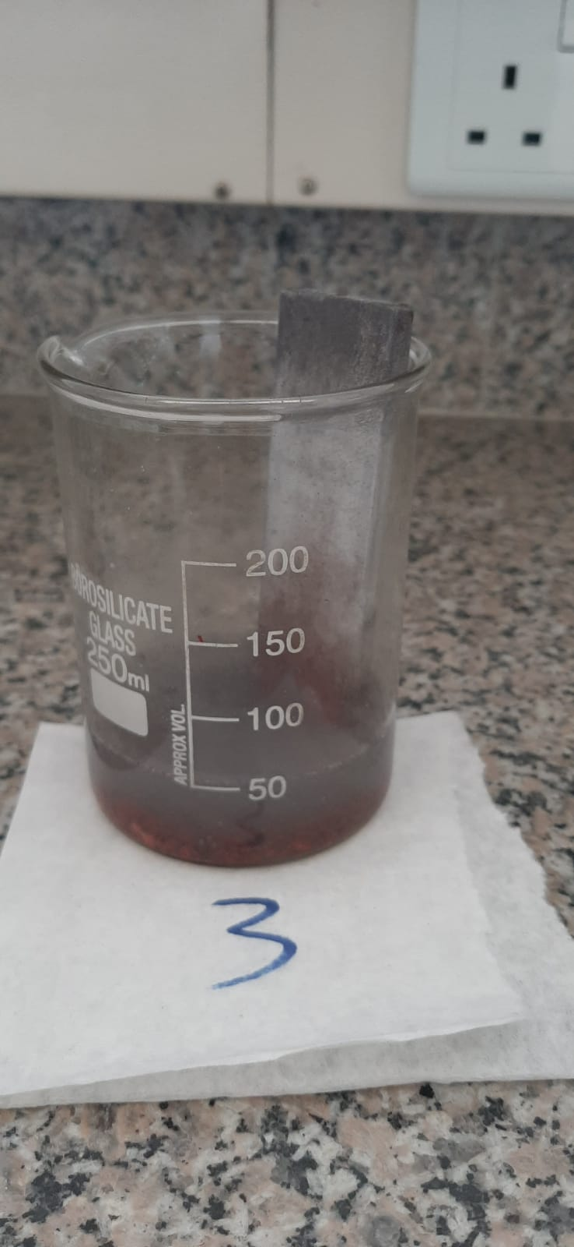
Figure 13

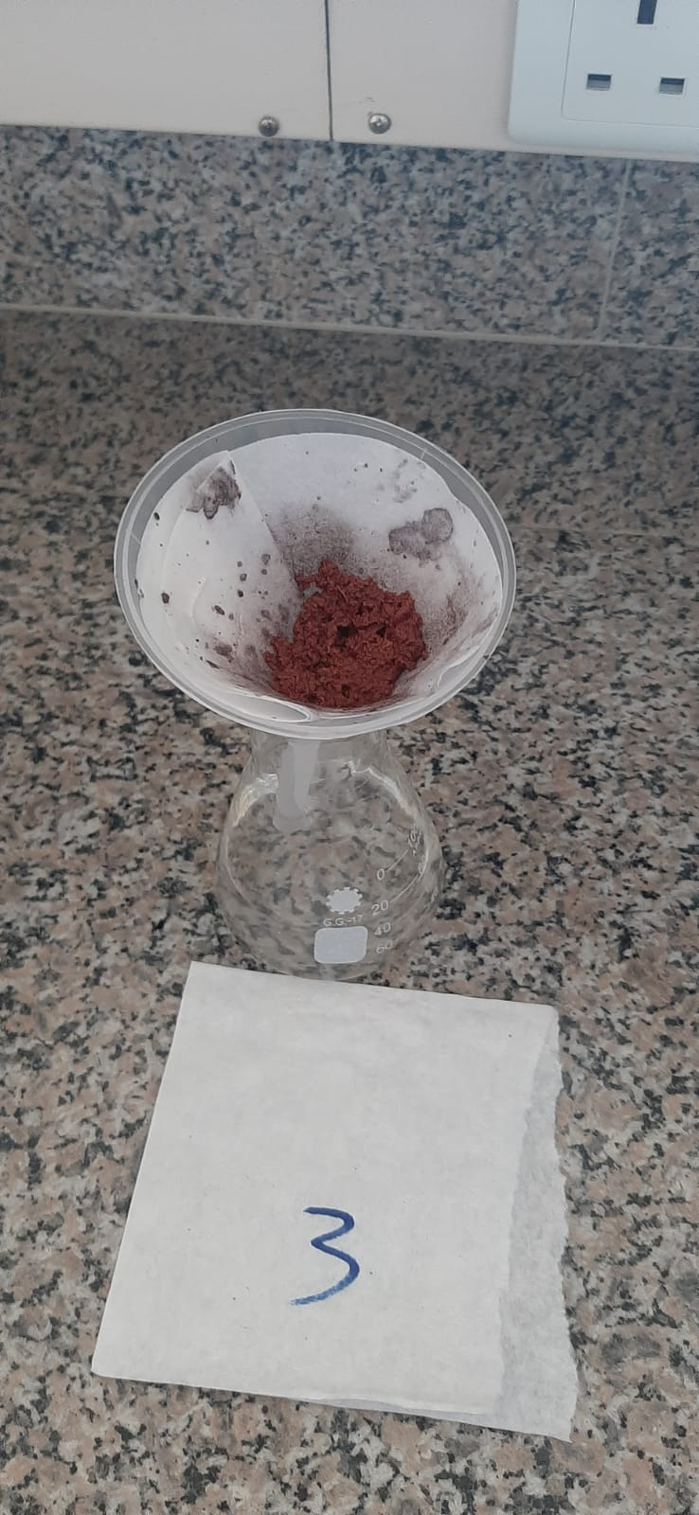
Figure 14
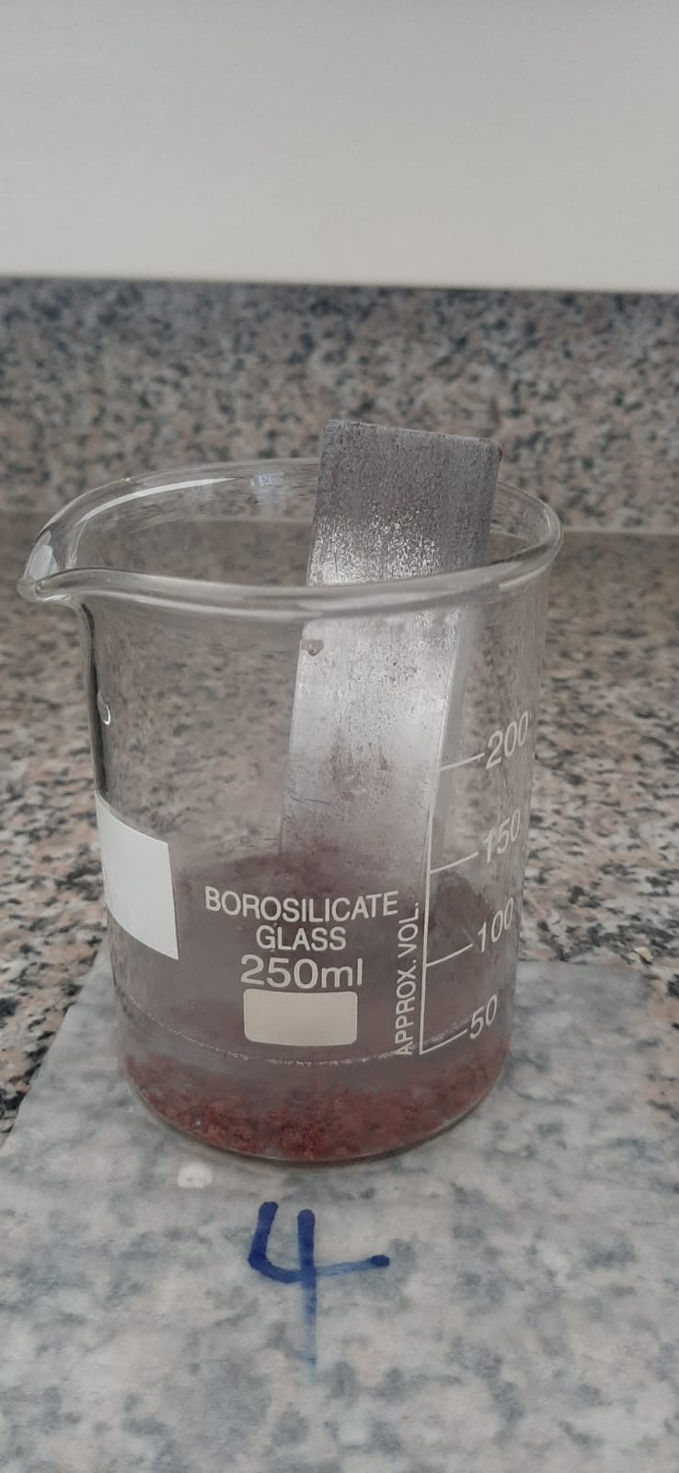
Figure 15
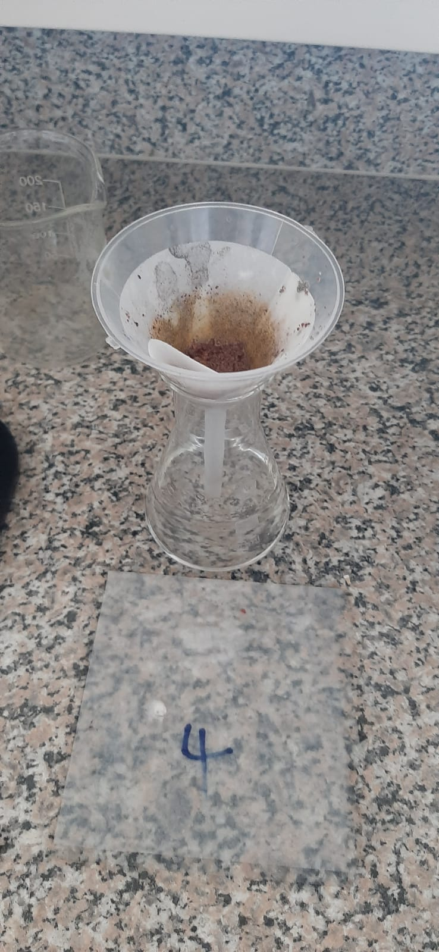
Figure 16
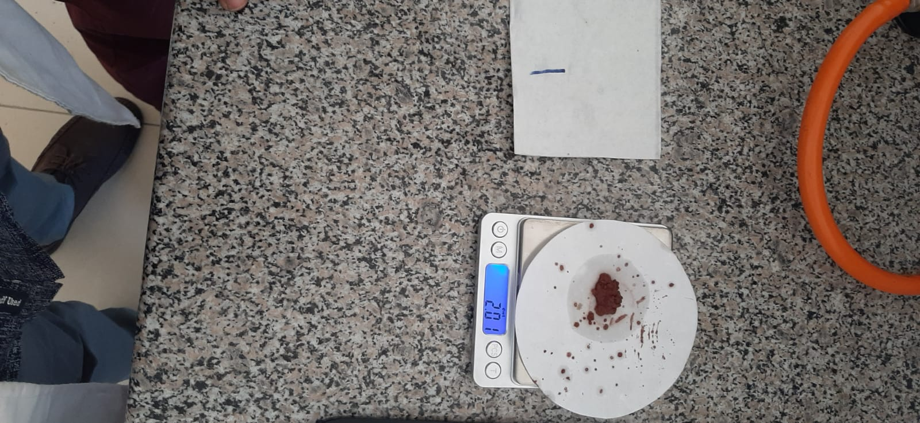
Figure 17

Figure 18

Figure 19

Figure 20

REFERENCES
Displacement Reactions—Definition, Types (Single & Double), Examples. (n.d.). BYJUS. Retrieved February 27, 2022, from https://byjus.com/chemistry/displacement-reactions/
The Law of Multiple Proportions | Introduction to Chemistry. (n.d.). Retrieved February 27, 2022, from https://courses.lumenlearning.com/introchem/chapter/the-law-of-multiple-proportions/
What is a Synthesis Reaction? (n.d.). Sciencing. Retrieved February 27, 2022, from https://sciencing.com/what-is-a-synthesis-reaction-13712164.html

